WHAT ABOUT THIS BOOK, THE BIBLE?

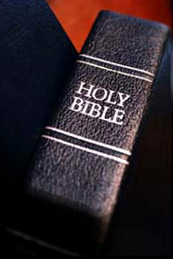
The Bible can be an intimidating book. With both the Old Testament and the New Testament there are easily over a thousand pages of material. How can someone hope to comprehend something so massive; especially if it is the Word of God? This study is meant to help us get a handle on the Bible and how it all fits together so the journey is a little more negotiable.

Share why the Scriptures have been important to you, if they have.

- THE TABLE OF CONTENTS.

Turn to the table of contents in your bible. If you are not familiar with the order of the books of the Bible you might put a marker at the table of contents to help navigate through Bible studies.

Note that the table of contents includes an Old and the New Testament. What would you say is the difference between the Old and New Testament? (Fundamentally the two testaments are covenants or agreements that have been set by God as he works with man. Other words for testament are covenant, agreement or even will; as in “last will and testament.”)

Read Hebrews 9:15-17

Jesus is noted as the mediator of a new covenant. When did that new covenant come into effect? (At the death of Jesus.)

We find ourselves at a time in history when the New Testament has been put into place as the agreement God has set forth for man to know God. The Old Testament is still Scripture and is inspired (we will explore that concept in another study), but the covenant for us because of the death of Jesus is found in the New Testament.

- THE OLD TESTAMENT
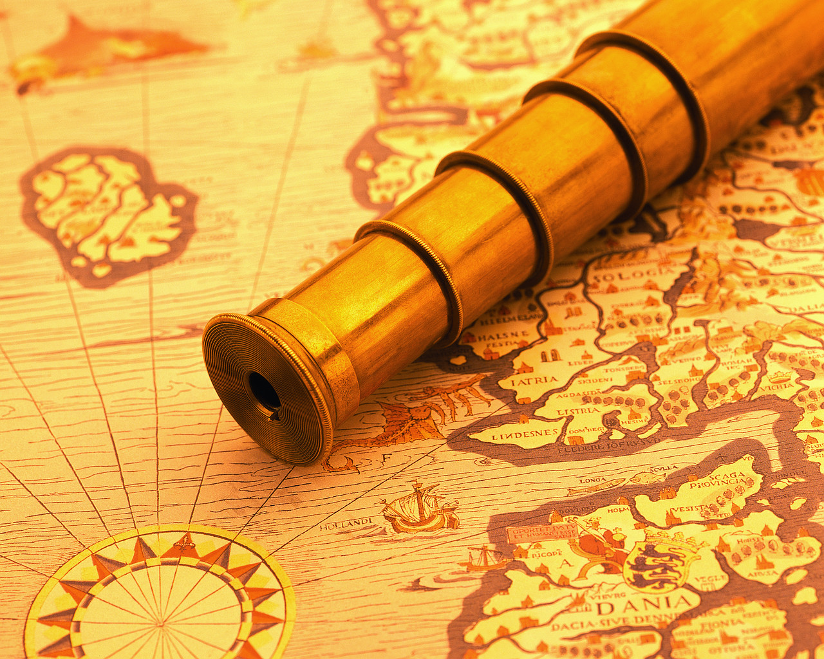
Turn back to the table of contents. The following material is meant to give you a general map of the Old Testament so you can know your way around the basic story of the Bible.

Genesis through Deuteronomy

This is known as the Law or the Pentateuch (meaning five). It contains the creation account, the fall of man, the establishment of nations and the choosing of one man and nation by which God will bless all nations. It also contains the Law of the Israelite nation so that they could live in fellowship with a holy God.
Joshua through Esther

These are books of history, which recount the works of God and Israel. God is molding a people to be his own so he can bless all nations. Most of the books called the major and minor prophets address a portion of this period of history, therefore the Old Testament table of contents is not arranged in chronological order. For example the preaching of Haggai and Zechariah (both minor prophets) occur during the time of the book of Ezra.
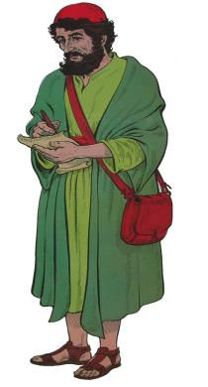
Job through Song of Songs

These are books of poetry and wisdom. Some books like Proverbs will have catchy sayings of practical wisdom. For example Solomon writes in Proverbs 14:30, “A heart at peace gives life to the body, but envy rots the bones.” Others like Ecclesiastes really need to be read in their complete context to get the point of the writer.

Isaiah through Daniel

These are called the major prophets because they are larger works. These prophets are primarily dealing with events within the nations of Israel or Judah and are spokesmen for God calling God’s people to live as God would have them.

Hosea through Malachi

These are called the minor prophets because they are smaller works. These prophets have the same role as the major prophets; to call people back to God and His ways.

- THE NEW TESTAMENT

Matthew through John

These are called the gospels (gospel means “good news”) and they deal with the life, death and resurrection of Jesus. They include the teachings, miracles, and life of Jesus.

Acts

This is a history of the early church. It covers about thirty years beginning with the resurrection of Jesus and His plan for the disciples to be witnesses in Jerusalem, Judea, Samaria and the ends of the earth. The events that unfold tell the story of the spread of the gospel of Jesus Christ.

Romans through Jude

These are all letters to Christians. Some are letters to churches, like Romans, and some are letters to individuals, like 1 Timothy. They deal with the Christian life under all sorts of different circumstances. For example: Paul writes to the church in Ephesians and shares, “In your anger do not sin.” This text is found in Ephesians 4:26 and deals with what it means to live as a Christian.
Revelation

This is an apocalyptic writing, meaning that it is highly symbolic. The apostle John writes in a time when the church is under persecution. He helps Christians see that God will be victorious and they must continue to be faithful to God. It is good to have a working knowledge of the rest of the New Testament when working through the book of Revelation due to the symbolic nature of this book.

- SOME THOUGHTS WHEN READING THE BIBLE

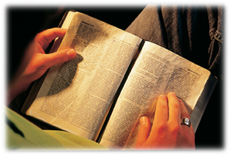
Start with the New Testament because it is the covenant that began with the death of Jesus Christ and it applies to us.

Since we are under the new covenant it makes sense to start with the part of the agreement that applies specifically to us today.

If you have not spent much time reading your Bible a great place to start is with the gospel of John.

Read John 20:30-31. What does John say his purpose in writing is? How would it be helpful to you to have your faith in God to grow?

Read 2 Peter 1:12-21

Peter wrote this short letter. What kind of evidence does Peter claim to have as he shares the life of Jesus? (He is an eyewitness.)

How does this claim of being an eyewitness help his credibility?

In verses 20-21, Peter indicates that Scripture is not a man’s own interpretation or did not originate with man. Where does Peter say Scripture comes from? (It comes from God and is given to men by the Holy Spirit.)

What encouragement do you receive by recognizing that God is communicating to us through Scripture?

Read Romans 10:14-17. From this verse, what is a way faith is developed in a person’s life? (Verse 17 – faith comes by hearing the word of Christ.)

Has anyone in this study seen their faith grow by spending time listening to the word of God when they have read their Bible? Would that person share about this experience? (How has your faith grown? How has that blessed your life? How has that challenged your life?)

The Journey. Even reading and contemplating on the Scriptures for at least five minutes each day will help to increase your faith and knowledge. May you be blessed in this journey. Try to spend time each day reading your Bible, it will bless your life.

