DISCIPLESHIP
(What Does It Mean To Follow Jesus?)
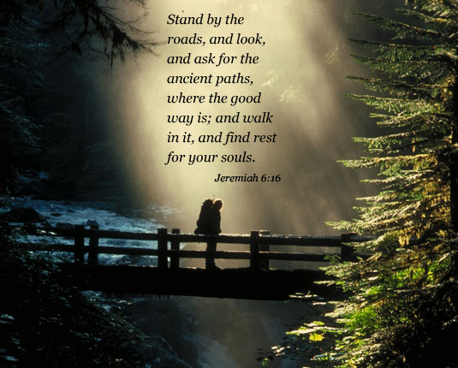
- Introduction

The word of choice by God, in Scripture, to describe someone who follows Jesus is “disciple.” We will use this study to examine the basic decisions needed to be a disciple of Jesus. We will also discover that being a disciple is tied to what it means to be a Christian.

Discipleship: Following Jesus

Acts 11:19 - 26
Who are called Christians in this text?
How many times do you think the word “Christian” is used in the Bible? ____ The word “Disciple”? ____
How would you define “disciple?”

Observations:
Jesus, John the Baptist, Moses, and others had disciples. A disciple is a follower or learner of another. Christians are followers of Jesus and are appropriately called disciples. A key concept for us is that to be a Christian, one must be a disciple of Jesus.

The word “Christian” occurs a total of three times in the New Testament (Acts 11:26; 26:28; 1 Peter 4:16). The word “disciple” occurs over 270 times in the New Testament. The use of Christian in Acts 11 may have been more derogatory than complimentary.

Luke 9:23 - 26
Who is Jesus speaking to?
What does it mean to “deny yourself?”
What was a cross used for in the times of Jesus? So what does Jesus mean when he says “take up your cross?”
What does it mean by the fact that Jesus adds the comment “daily” to this cross?
What does it mean to follow Jesus?

Observations:
He said to them all, “If anyone...” Jesus is not speaking to a select few or to those who wanted to be super committed. The call to be a disciple is the same for all people of all times.

He must deny himself – We are to surrender to God’s will. Most parents do not get up at 3:00 A.M. to look after a crying baby because they feel good about it. Instead, a parent’s love for their child carries a deep commitment that does the uncomfortable. A person may not “feel” like meeting with Christians at assemblies, praying, overcoming sin, etc. Yet, we need to follow Jesus whether we feel like it or not.

Take up your cross daily - Most people think a person is really committed if they attend church services each week. Jesus teaches we must be his followers every day, not merely on Sunday.

Luke 14:25 – 33
What does Jesus mean when he says “hate?” Turn to Matthew 10:37-38 and compare what Jesus says in these two texts.
List the three things necessary to be Jesus’ disciple.
Why these three areas?
What kind of relationship does Jesus call you to have with him?
What does Jesus say needs to happen with sin, self and your selfish desires?
What does Jesus mean when he says that we must give up everything to be His disciple?
What is the point of the tower?
What is the point of the two kings?

Observations:
If anyone comes...again Jesus is not talking to a select few, but to anyone who wants to follow Him. Three times (verses 26, 27, 33) Jesus proclaims the conditions of being His disciple.

Unrivaled love in verse 26. A person’s love for Christ must be greater than his or her love for any other individual or thing. The word “hate” sometimes bothers us. The word in its context means “to love less,” not animousity. This concept is clearly set forth in Matt. 10:37-38. Jesus is saying in comparison to Him, we must love others less. The reason he chooses father, mother, brothers, sisters, wives, etc. is that these are the people who normally have the greatest influence in our lives. A person must consider the reaction of their close family and friends so they are prepared for any negative consequences to the choice of following Jesus. People may find this very challenging so there is a need to consider the following:

Those who choose Jesus are not always rejected by family. In fact, becoming a Christian may improve family relationships. But all followers of Jesus must choose to make Jesus first in their life! This complete commitment to Christ should not be a strange concept to our thinking. In a marriage, the bride and groom agree to a complete and exclusive relationship with one another. The plan is not a 95% commitment to their spouse with 5% devoted to a different lover. The marriage covenant calls for 100%. Jesus also calls for a 100% commitment.

Unceasing dying in verse 27. The cross calls for death to self and selfish desires. By God’s power we put to death sin and are prepared to suffer persecutions and hardships for our Lord and Savior, if and when those circumstances arise.


Unconditional surrender in verse 33. A person must be willing to give up everything, not just anything. Some specific areas that need to be turned over to God’s control are:

- Be the best employee or student we can be.
- Strive for excellence in whatever we do.
- Christ must be the number one priority in our life.
- Jesus becomes the owner of our life, relationships, money, possessions and future. We give ownership to Jesus and manage our lives under God’s ownership.


The tower in verses 28-30. Jesus deals with counting the cost of following him by using a parable about a man building a tower. We know it is foolish to start to build and then be unable to finish. The world ridicules such people. Jesus is using this parable to get us to count the cost so we will be faithful as a disciple/Christian.

The two kings in verses 31-32. Jesus calls us to count the cost of not following him. This is a parable of two opposing armies. The King with 20,000 represents God and Jesus, while the king with 10,000 represents each of us. The point is that the king with 10,000 is going to be defeated by the greater king.

Jesus is saying a person must consider the alternatives. If we choose to make war with God (refuse to submit to His will) we will be destroyed. But, if we make peace (unconditionally surrenders to His will) then we will be saved. In the first parable (the tower) a person is urged to count the cost of following Jesus. In the second parable (the two armies) a person is reminded of the consequences of not following Jesus.

Acts 2:42-47
Who is being talked about in this text?
A________
T________:
Bible Study
What does it mean to devote yourself to something?
What four things did they devote themselves to and what do they stand for today?

Observations:
The first Christians/disciples made Jesus their Lord. He was the center of their lives. They devoted themselves to the apostles teaching (Bible study), fellowship (Christian relationships), breaking of bread (Lord’s supper and the concept of grace), and prayer. We should devote ourselves to the same things. Like four spokes in a wheel, when we keep Jesus at the center of our lives and these four aspects of our discipleship healthy, we tend to stay healthy spiritually and not break down.

Jesus
F________
B_______
B______:
Grace
P_______

Today
Eternity

The Christian Life
Is Full Of Bumps So Keep All The Spokes In Place.

Conclusion: Are you a disciple of Jesus?

What will it take for you to decide to build your life on Christ and to make peace with God?

