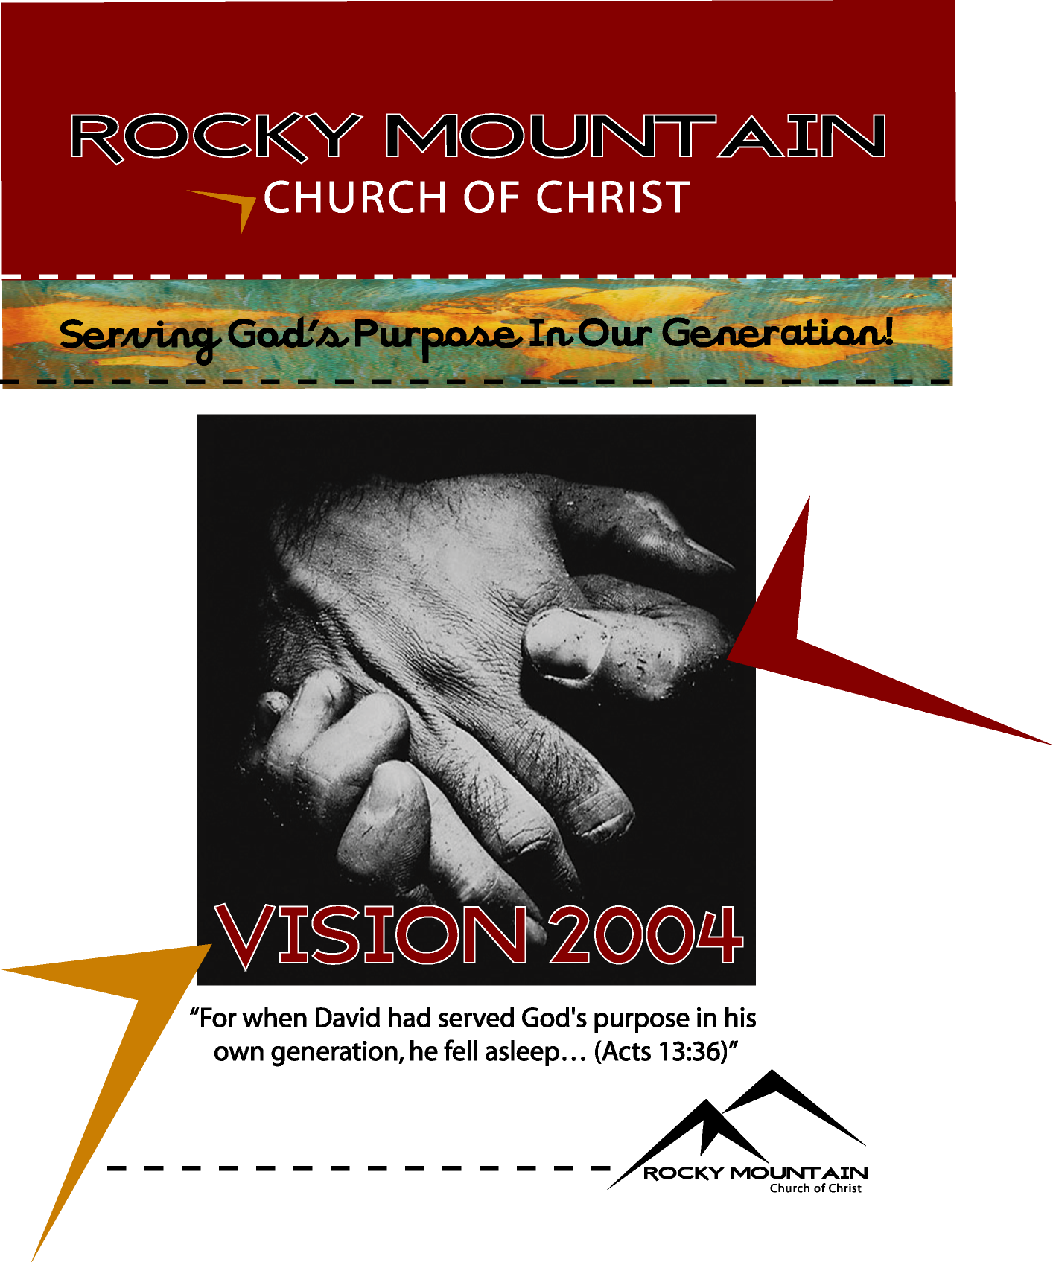

Introduction
The Rocky Mountain Church is an undenominational group of Christians committed to knowing Christ, growing in Christ, and sharing Christ with the world. We are a Purpose- Driven, Cell-Based Church which means that we have very specific goals in mind and a very specific method we use to achieve those goals. Our Cell Groups (LIFE Groups) are an integral part of our ministry model. We have a purpose for existing, and that is to impact our generation with the good news about Christ and His resurrection. This year’s theme is, “Serving God’s Purpose In Our Generation.” This theme will focus us our mission of reaching the lost and growing a great church in Helena and being a model church to inspire others around the world.
Our plans for the year 2004 are designed to help us accomplish our objective of changing lives in our generation in the most effective manner possible with the powerful message of the Gospel. This plan takes into consideration the culture and times in which we live and attempts to adapt our approach to the world and our culture without changing or altering the Gospel message. "Though I am free and belong to no man, I make myself a slave to everyone, to win as many as possible. To the Jews I became like a Jew, to win the Jews. To those under the law I became like one under the law (though I myself am not under the law), so as to win those under the law. To those not having the law I became like one not having the law (though I am not free from God's law but am under Christ's law), so as to win those not having the law. To the weak I became weak, to win the weak. I have become all things to all men so that by all possible means I might save some. I do all this for the sake of the gospel, that I may share in its blessings" (1 Corinthians 9:19-23).
Paul stated that the foundation upon which we must build is Christ. We, however, must be careful how we build on that foundation so that we will build a church to the glory of God as Wise Master Builders, "So neither he who plants nor he who waters is anything, but only God, who makes things grow. The man who plants and the man who waters have one purpose, and each will be rewarded according to his own labor. For we are God's fellow workers; you are God's field, God's building. By the grace God has given me, I laid a foundation as an expert builder, and someone else is building on it. But each one should be careful how he builds. For no one can lay any foundation other than the one already laid, which is Jesus Christ" (1 Corinthians 3:7-11).
Our church is based upon three simple concepts that help to illustrate our model of ministry: 1) Five Circles, 2) a Baseball Diamond , and 3) a Hand. The five circles help us program by purpose, and the baseball diamond guides us to educate by purpose, and the hand identifies our five driving purposes.
The five circles represent five levels of commitment. The objective of our program is to draw people from the outer circles into the inner circles, train them, and then send them back out. Each ring has its own activities and objectives. For instance, there are activities specifically designed to bring people from the community so that we create a crowd. These include TV, ads, campaigns, seminars, radio, newspaper, or any other activities that accomplish this objective.

There are other activities designed to draw people from the congregation to a deeper commitment, and other activities designed to draw people from the committed into the core for leadership and ministry development training.
The baseball diamond has four bases. First base is commitment to membership, second is commitment to maturity, third is committed to ministry, and home base is committed to missions. Our educational program is tied into this concept, and the goal is to get people around the bases. Classes and curriculum can be adapted as needed to accomplish this concept.
Each base on the diamond will have a team that will oversee the design and accomplishment of the purpose of that base. The mission team will oversee the accomplishment of getting people into Christ and His church. Any task involved in that purpose will be the responsibility of the mission team and those working in that area. All transfer members take this course before placing their membership at the Rocky Mountain Congregation and all newly baptized members take this course to commit to the mission of the Rocky Mountain mission.
The maturity and membership team will be responsible for overseeing the accomplishment of getting new members connected to the church and to maturity in Christ. Any task or classes that accomplish that goal will be the responsibility of the maturity team and those working in that area.
The ministry equipping team will be responsible for overseeing the task of getting people committed to participating in ministry. At this point, people who are maturing in Christ will be trained to develop effective ministries utilizing their God given SHAPE. These ministries will be tied into the overall purpose of the church. Unlimited numbers and types of ministries can be developed to care for the needs of people both inside and outside the body with the ultimate purpose of winning them to Christ, growing them up in Christ, and equipping them to also create ministries for Christ.
All the ministry teams will be developed over time as the church progresses to that point. Utilizing this concept in its intended manner allows God to direct the nature and personality of this church with the spiritual gifts that He provides within the body. Ministries will be started by those who are committed to membership at Rocky Mountain and are maturing in Christ and who have that particular set of spiritual gifts that enables them to minister in that particular area. As people are brought to membership in the body, matured in Christ, and trained and equipped for ministries utilizing their spiritual gifts, the body will grow naturally as each member does its part. This is the Biblical pattern found in Ephesians 4:11-16.
Our ministry model is driven by five Biblical purposes 1) Honoring God - the first commandment, 2) Loving People - the second command, 3) Evangelism - the Great commission, 4) Edification - education and maturity of our members, and 5) Equipping - training and involving each member in meaningful ministry. We use a hand illustration to communicate those purposes.
As we enter the year 2004, we feel certain that we have only laid the foundation upon which we will see this church have an even more dynamic impact on our generation, not only in this city and this state, but throughout the world.
Our goal continues to be for the kingdom, the souls of men, and to the praise of His glorious grace. We will Serve God’s Purpose In Our Generation!

Rocky Mountain Trends

We Program By Purpose
The Core: Those Committed to Ministry
The Committed: Committed to Maturity
The Congregation: Committed to Membership
The Crowd: Regular Attenders to Worship
The Community: Occasional Attenders and Unchurched
GOAL: To move people from outer ring inwardly, then back out to be involved in ministry to help win the world to Christ.

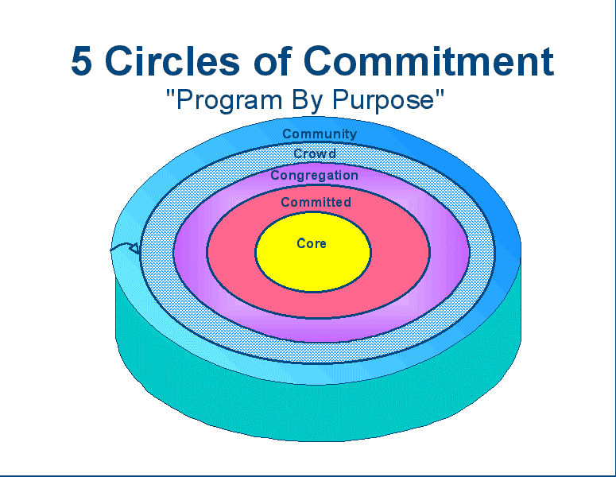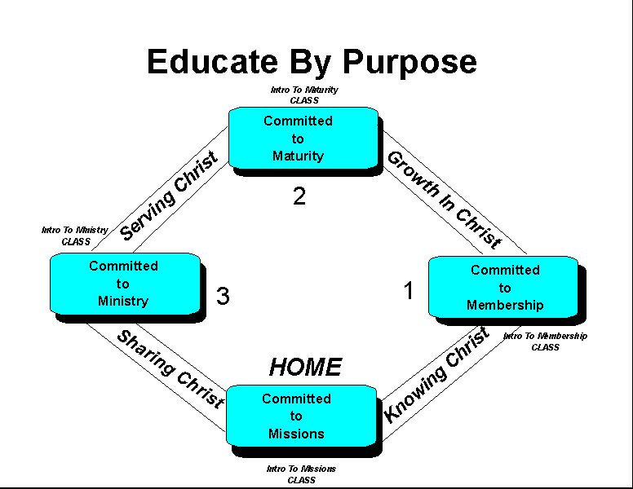
Christian Life And Service Seminars (CLASS)
Introduction To Membership To lead people to Christ and Membership in the local church
Helps people from “The Crowd” to make a commitment to membership - “The Congregation”

Introduction To Maturity: To grow people to spiritual Maturity and stability
Helps people from “The Congregation” become “Committed” to the habits of spiritual maturity.

Introduction To Ministry: To equip people with skills they need for their personal Ministry
Helps people move from “The Committed” to “The Core” as they identify their spiritual gifts and talents and develop actual ministries within the body.

Introduction To Missions: To help people define and fulfill God’s Mission in the World

IMPORTANT: We want every member to be a “Grand Slam” disciple. You don’t get to stay on base! We want every member to be committed to the mission and purpose and help to achieve it for Christ.

Our Purposes
The RMC is a purpose driven church. We have five main purposes that directly relate to our five circles and four bases:
1. Honor God
"Teacher, which is the greatest commandment in the Law?" Jesus replied: "'Love the Lord your God with all your heart and with all your soul and with all your mind.' This is the first and greatest commandment"' (Matthew 22:36-38).
The greatest commandment we have is to Love the Lord, therefore our plan and purposes must accomplish this objective. In order to fulfill this command, two major objectives will be addressed - 1) Our public worship assembly, and 2) The private devotion of each member.
Our plan will concentrate on creating and maintaining an excellent worship assembly that is intended to help each member glorify and exalt the Lord in all His Majesty. The plan will also address practical ways of helping each member develop and maintain private devotional lives that honor the Lord and help each member love the Lord with all his or her heart, soul, mind, and emotion.
2. Love People
"And the second is like it: 'Love your neighbor as yourself.' All the Law and the Prophets hang on these two commandments"' (Matthew 22:39-40).
The second commandment is to love people in practical, meaningful and encouraging ways. Therefore, the plan will address ways to help the congregation as a whole and each individual member become effective in ministry to serving and loving people

3. Evangelism
"Then Jesus came to them and said, "All authority in heaven and on earth has been given to me. Therefore go and make disciples of all nations, baptizing them in the name of the Father and of the Son and of the Holy Spirit" (Matthew 28:18-19).
It is God's will that people come to know Him and be saved. Our motto, The Commission Is Our Mission reflects God's will for the Rocky Mountain Church. Our plan addresses practical and meaningful ways for the congregation as a whole and individual members to be effective in evangelism in an on-going way. This portion of the plan helps people get to first base - Committed to membership. It addresses our objective of getting the community to become a crowd and then becoming part of the congregation.
4. Edification
"... and teaching them to obey everything I have commanded you. And surely I am with you always, to the very end of the age" (Matthew 28:20).

"Then we will no longer be infants, tossed back and forth by the waves, and blown here and there by every wind of teaching and by the cunning and craftiness of men in their deceitful scheming. Instead, speaking the truth in love, we will in all things grow up into him who is the Head, that is, Christ" (Ephesians 4:14-15).

This portion of our plan addresses practical and meaningful ways of getting members from “Committed To Membership”, to “Committed to Maturity”. This will involve the entire educational process of the church, our Bible classes, LIFE Groups, sermon topics, etc.
5. Equipping
"It was he who gave some to be apostles, some to be prophets, some to be evangelists, and some to be pastors and teachers, to prepare God's people for works of service, so that the body of Christ may be built up" (Ephesians 4:11-12).
The equipping portion of the plan will deal with practical ways of helping each member become involved and/or create productive ministries that help us achieve the previous four purposes. Mature members will be assisted to become productively involved in the ministry of this church to outsiders and other members. Equipping people will take into consideration their SHAPE (Spiritual Gifts, Heart, Abilities, Personality, and Experience). The church will grow, and members will become mature as they are equipped for works of service.

Our Five Purposes:

2004 Goals, Objectives, and Activities
I. Committed To Membership Ministry Objective: Getting People Committed To Membership.
Target: Community and Crowd to bring them into the Congregation as committed members.
Ministry Leader: Greg King
A. By December 30, 2004, the following items will have been accomplished:
Begin a regularly scheduled “Seeker’s Class” to introduce people to Christ.
Teach New Member’s Class January 11th , March 7th , June 27th, September 12th
Continue, improve and adapt TV ads as needed on KTVH, ch 12
Continue to set up one on one studies and average 8 studies per week.
Complete Five Bring Your Neighbor Day Outreach Campaigns (March 7th , Easter -April 11th, Father’s Day - June 20th, September 12th, and Christmas - December 18th )
Continue to send visitors welcome letter after they visit (Dick & Kathy Subry)
Goal for conversions "34 in 2004"

B. Things needed to accomplish above tasks
Greg to develop the mission team
Develop an effective “One Shot” study to be used by our members.
Teach Effective Evangelism Class in Effective Evangelism Workshops as needed, using our new training video.
Develop a TV Ad on Baptism and being born again.

II. Committed To Maturity Ministry: Objective: Getting People To Commit To The Habits of Spiritual Maturity.

Target: Congregation to bring them into Committed
Maturity Ministry Leader: Jerry Botts
The objective of the maturity ministry is to move the new member from first base (committed to membership) to second base (committed to maturity). This is to be accomplished through the use of our existing courses, “Second Teach” ministry, small groups, and other fellowship & ministry activities that we have developed.
A. By December 30, 2004 the following items will have been completed:
Maturity minister will track the integration and follow-up of new members. All new members should complete the classes that we have developed (Second Teach, and New Beginnings). This will accomplish two objectives: 1. Insure that new members are properly cared for, matured, and nurtured. 2. Insure that all new members are fully informed of our ministry style and model and safeguard the congregtion so that doctrinal purity is maintained and that unity is preserved as we advance with one mind and one purpose.
Teach Maturity Class in our Super Sunday Events January 11th , March 7th , June 27th, September 12th
Insure that all members are integrated into the LIFE of our Small Group Ministry.
Host 7th annual "Rocky Mountain Great Commission Workshop", June 11th – 13th .
Teach the Life Group leader training course to recruit and train more small group leaders on an as needed basis
Develop five additional couples for “Second Teach” ministry.
Teach New Beginnings courses beginning in January

III. Committed To Ministry: Objective: To Get Members Trained And Equipped For Core Ministries.
Target: Committed to bring them into Core Ministries

Ministry leaders: Dick Subry & Richard Jackson
Our goals:
Teach Ministry Course as needed
Help members complete their SHAPE profile and discover individual ministries through a Ministry Development Fair.
Develop Ministry “Booths” with sign up sheets and brochures to highlite each ministry as a means of informing and recruiting people for individual ministries. The booths will be developed by April 15th and prepared in advance for the Purpose Driven Life series.
Have Dick develop a data base listing the spiritual gifts analysis scores from the York Gifts Analaysis for each member.
Begin a Recovery Ministry (Dan Brown, Courtney Smith, Greg King)

KEY: We want every member to find his or her gifts, talents and abilities and then create an effective ministry that will utilize those individual abilities.
“Each one should use whatever gift he has received to serve others, faithfully administering God’s grace in its various forms” (1 Peter 4:10).

IV. Committed To Missions: Objective: Train every member to be involved in winning the lost to Christ through personal evangelism and help the congregation be effective in equipping other churches grow and win the lost.
Ministry Leader: Greg King
The mission team are those in the congregation whose primary talents deal with effective personal evangelism Our LIFE Groups are involved in this ministry, as are our mail-out publications, nation wide publications, and Web page ministry.
Here are the goals for 2004
Average 8 one on one Bible studies per week as a congregation
Convert 34 people in 2004 in Helena
40 Days of Purpose Campaign beginning May 2nd
A LIFE Group leader’s training seminar will be conducted throughout the year as needed.
Greg will conduct Great Commission Workshops as requested by other congregations (Muscatine, Iowa, Oregon City, Oregon, Vernon, BC, Canada)
Continue to publish and distribute growth and evangelism materials via Internet.
Assist other churches with their work in evangelism and growth as requested.
Begin planting seeds for church plantings in Montana (Lincoln, Townsend, Deer Lodge…)
Greg to complete certification as a “Church Growth Consultant”

V. Honoring God: Objective: Create an excellent, vibrant, enthusiastic, and reverent worship service that helps Christians praise God and encourage one another, while still remaining seeker sensitive and inspiring to the unchurched.
Ministry Leader: Rusty Linden
Rusty Linden has dediced to attend Oklahoma Christian University and go into full-time ministry and will be leaving in June, 2004. With that in mind, we need to recruit another effective Worship Leader so the quality of our worship continues to increase.
The worship and praise team will facilitate worship planning with our primary objective and responsibility to worship God in spirit and in truth. This planning endeavors to insure that everyone will participate in meaningful, reverent, inspiring, and vibrant worship.
The areas of worship that we have concentrated on are Sunday Morning, Devotionals, and Special Occasions. Maintaining a celebrative worship environment enhances our evangelistic and maturity plans.
Recruit a new Worship Leader, utilizing Websites from ACU, Harding, Pepperdine, Christian Chronicle and other Christian networking areas.
Develop a training workshop for the men who participate at every level of the worship service to enhance a meaningful worship experience for the church.
Continue singing our new songs in worship until they become second nature.
Continue to streamline Worship Services for enriched participation and quality of worship.
Worship team will develop helpers and contact list for those to serve during our worship times. (Barto Tocas)
Assign Ushers and train them to “Greet & Seat” properly (Have Marvin work with Barto on this). Greeters should be positioned at front door on time, at the door to the auditorium, and should greet visitors as they leave and insure they have a Bible, a “Welcome to Rocky Mountain” tape, and brochures.

Supplimental Ideas and Goals

The following are additional items and information the church needs to be informed of as we plan for 2004.
- We will be hosting Accappella, the singing group that will be here for our Great Commission Workshop June 12-13th .
- A recovery ministry for those wanting to recover from drug and alcohol addictions will being in January.
- Greg will preach three series during the year:
- Road To Recovery (Beginning in January)
- Purpose Driven Life Campaign (40 days of Purpose… to finale in June at our Great Commission Workshop)
- Sermon on the Mount….. June through December….

Our land purchase is progressing through the slow stage of state, city and now federal channels, but it looks like we should be able to finally close this year. A developer has made a proposal to the city & county and they have accepted his drawings. Our property will be close to the new Saddle Drive interchange that will connect with I-15. There are sites on both sides of the interstate for an estimated 2,500 new homes to be built over the coming years, so we will be well positioned to have a great influence on families.

A fund raising campaign will need to be developed to help with purchasing our building.

Closing Comments

The year 2003 was a wonderful year for the Rocky Mountain Church! The unity feels great and the love among us is abundantly obvious. The Lord has been bringing us a continual stream of new people who want to love the Lord.
We are members of one another and that is very apparent in what is happening in this body. God is working something Great in our lifetime! We are part of it!

Three things that must continue and increase –
- Relationship with God through prayer and personal devotion, and
- Relationships with one another
- Relationships with those who are lost.
I’m so proud to be an evangelist with this church and so honored to be your brother in Christ.
Love God. Love Others. Go make Disciples!

Greg King

