

We exist to bring people to Christ and membership in His church, grow every member for his or her ministry so they fulfill their life’s mission in order to magnify God.

Introduction
Published July 30, 2026

The Rocky Mountain Church of Christ (RMCC) is an undenominational group of Christians committed to knowing Christ, growing in Christ, and sharing Christ with the world. We are a Purpose- Driven Life Group-Based Church, which means that we have very specific goals in mind and a very specific method we use to achieve those goals. Our LIFE Groups are an integral part of our ministry model. We have a purpose for existing, and that is to impact our generation with the good news about Christ and His resurrection. This year’s theme is, “Serving God’s Purpose In Our Generation.” This theme will focus us on our mission of reaching the lost and growing a great church in Helena and being a model church to inspire others around the world.
Our plans for the year 2006 are designed to help us accomplish our objective of changing lives in our generation in the most effective manner possible with the powerful message of the Gospel. This plan takes into consideration the culture and times in which we live and attempts to adapt our approach to the world and our culture without changing or altering the Gospel message. "Though I am free and belong to no man, I make myself a slave to everyone, to win as many as possible. To the Jews I became like a Jew, to win the Jews. To those under the law I became like one under the law (though I myself am not under the law), so as to win those under the law. To those not having the law I became like one not having the law (though I am not free from God's law but am under Christ's law), so as to win those not having the law. To the weak I became weak, to win the weak. I have become all things to all men so that by all possible means I might save some. I do all this for the sake of the gospel, that I may share in its blessings."
(1 Corinthians 9:19-23)
Paul stated that the foundation upon which we must build is Christ. We, however, must be careful how we build on that foundation so that we will build a church to the glory of God as Wise Master Builders, "So neither he who plants nor he who waters is anything, but only God, who makes things grow. The man who plants and the man who waters have one purpose, and each will be rewarded according to his own labor. For we are God's fellow workers; you are God's field, God's building. By the grace God has given me, I laid a foundation as an expert builder, and someone else is building on it. But each one should be careful how he builds. For no one can lay any foundation other than the one already laid, which is Jesus Christ." (1 Corinthians 3:7-11).
Our church is based upon three simple concepts that help to illustrate our model of ministry: (1) Five Circles, (2) a Baseball Diamond, and (3) a Hand. The five circles help us program by purpose, and the baseball diamond guides us to educate by purpose, and the hand identifies our five driving purposes.
The five circles represent five levels of commitment. The objective of our program is to draw people from the outer circles into the inner circles, train them, and then send them back out. Each ring has its own activities and objectives. For instance, there are activities specifically designed to bring people from the community so that we create a crowd. These include TV, ads, campaigns, seminars, radio, newspaper, or any other activities that accomplish this objective.
There are other activities designed to draw people from the congregation to a deeper commitment, and other activities designed to draw people from the committed into the core for leadership and ministry development training.
The baseball diamond has four bases. First base is commitment to membership, second is commitment to maturity, third is committed to ministry, and home base is committed to missions. Our educational program is tied into this concept, and the goal is to get people around the bases. Classes and curriculum can be adapted as needed to accomplish this concept.
Each base on the diamond will have a team that will oversee the design and accomplishment of the purpose of that base. The mission team will oversee the accomplishment of getting people into Christ and His church. Any task involved in that purpose will be the responsibility of the mission team and those working in that area. All transfer members and newly baptised members that want to become involved in the leadership take this course to commit to the mission of RMCC.
The maturity and membership team will be responsible for overseeing the accomplishment of getting new members connected to the church and to maturity in Christ. Any task or classes that accomplish that goal will be the responsibility of the maturity team and those working in that area.
The ministry equipping team will be responsible for overseeing the task of getting people committed to participating in ministry. At this point, people who are maturing in Christ will be trained to develop effective ministries utilizing their God given SHAPE (Spiritual Gifts, Heart, Abilities, Personality, and Experience). These ministries will be tied into the overall purpose of the church. Unlimited numbers and types of ministries can be developed to care for the needs of people both inside and outside the body with the ultimate purpose of winning them to Christ, growing them up in Christ, and equipping them to also create ministries for Christ.
All the ministry teams will be developed over time as the church progresses to that point. Utilizing this concept in its intended manner allows God to direct the nature and personality of this church with the spiritual gifts that He provides within the body. Ministries will be started by those who are committed to membership at Rocky Mountain and are maturing in Christ and who have that particular set of spiritual gifts that enables them to minister in that particular area. As people are brought to membership in the body, matured in Christ, and trained and equipped for ministries utilizing their spiritual gifts, the body will grow naturally as each member does its part. This is the Biblical pattern found in Ephesians 4:11-16.
Our ministry model is driven by five Biblical purposes (1) Honoring God - the first commandment, (2) Loving People - the second command, (3) Evangelism - the Great commission, (4) Edification - education and maturity of our members, and (5) Equipping - training and involving each member in meaningful ministry. We use a hand illustration to communicate those purposes.
As we enter the year 2006, we feel certain that we have only laid the foundation upon which we will see this church have an even more dynamic impact on our generation, not only in this city and this state, but throughout the world.
Our goal continues to be for the kingdom, the souls of men, and to the praise of His glorious grace. We will Serve God’s Purpose In Our Generation!

Rocky Mountain Trends

We Program By Purpose
The Core: Those Committed to Ministry
The Committed: Committed to Maturity
The Congregation: Committed to Membership
The Crowd: Regular Attendees to Worship
The Community: Occasional Attendees and Unchurched

GOAL: To move people from outer ring inwardly, then back out to be involved in ministry to help win the world to Christ.
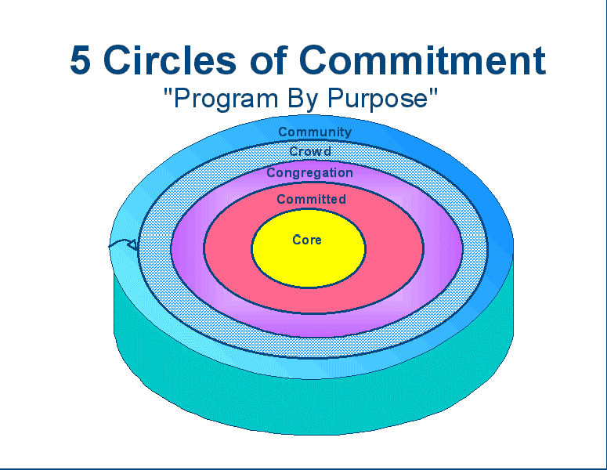
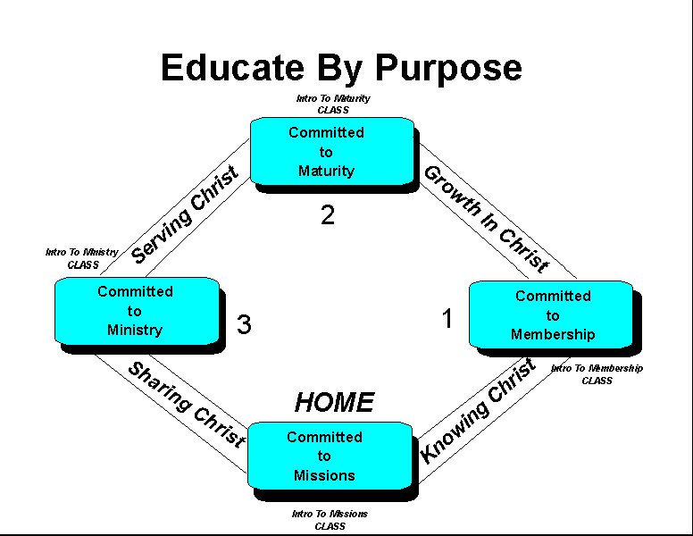
Christian Life And Service Seminars (CLASS)
Introduction To Membership:
To lead people to Christ and Membership in the local church
Helps people from “The Crowd” to make a commitment to membership -
“The Congregation”

Introduction To Maturity:
To grow people to spiritual Maturity and stability
Helps people from “The Congregation” become “Committed” to the habits of spiritual maturity.

Introduction To Ministry:
To equip people with skills they need for their personal Ministry
Helps people move from “The Committed” to “The Core” as they identify their spiritual gifts and talents and develop actual ministries within the body.

Introduction To Missions:
To help people define and fulfill God’s Mission in the World

IMPORTANT: We want every member to be a “Grand Slam” disciple. You don’t get to stay on base! We want every member to be committed to the mission and purpose and help to achieve it for Christ.
Our Purposes
The RMCC is a purpose driven church. We have five main purposes that directly relate to our five circles and four bases:

- Honor God
"Teacher, which is the greatest commandment in the Law?" Jesus replied: "'Love the Lord your God with all your heart and with all your soul and with all your mind.' This is the first and greatest commandment"' (Matthew 22:36-38).
The greatest commandment we have is to Love the Lord, therefore our plan and purposes must accomplish this objective. In order to fulfill this command, two major objectives will be addressed – (1) Our public worship assembly, and (2) The private devotion of each member.
Our plan will concentrate on creating and maintaining an excellent worship assembly that is intended to help each member glorify and exalt the Lord in all His majesty. The plan will also address practical ways of helping each member develop and maintain private devotional lives that honor the Lord and help each member love the Lord with all his or her heart, soul, mind, and emotion.

- Love People
"And the second is like it: 'Love your neighbor as yourself.' All the Law and the Prophets hang on these two commandments"' (Matthew 22:39-40).
The second commandment is to love people in practical, meaningful and encouraging ways. Therefore, the plan will address ways to help the congregation as a whole and each individual member become effective in ministry to serving and loving people.

- Evangelism
"Then Jesus came to them and said, "All authority in heaven and on earth has been given to me. Therefore go and make disciples of all nations, baptizing them in the name of the Father and of the Son and of the Holy Spirit" (Matthew 28:18-19).
It is God's will that people come to know Him and be saved. Our motto, The Commission Is Our Mission reflects God's will for RMCC. Our plan addresses practical and meaningful ways for the congregation as a whole and individual members to be effective in evangelism in an on-going way. This portion of the plan helps people get to first base - Committed to Membership. It addresses our objective of getting the community to become a crowd and then becoming part of the congregation.

- Edification
"... and teaching them to obey everything I have commanded you. And surely I am with you always, to the very end of the age" (Matthew 28:20).

"Then we will no longer be infants, tossed back and forth by the waves, and blown here and there by every wind of teaching and by the cunning and craftiness of men in their deceitful scheming. Instead, speaking the truth in love, we will in all things grow up into him who is the Head, that is, Christ" (Ephesians 4:14-15).

This portion of our plan addresses practical and meaningful ways of getting members from “Committed To Membership”, to “Committed to Maturity”. This will involve the entire educational process of the church, our Bible classes, LIFE Groups, sermon topics, etc.

- Equipping
"It was he who gave some to be apostles, some to be prophets, some to be evangelists, and some to be pastors and teachers, to prepare God's people for works of service, so that the body of Christ may be built up" (Ephesians 4:11-12).
The equipping portion of the plan will deal with practical ways of helping each member become involved and/or create productive ministries that help us achieve the previous four purposes. Mature members will be assisted to become productively involved in the ministry of this church to outsiders and other members. Equipping people will take into consideration their SHAPE (Spiritual Gifts, Heart, Abilities, Personality, and Experience). The church will grow, and members will become mature as they are equipped for works of service.

Our Five Purposes:

2006 Goals, Objectives, and Activities

I. Committed To Membership Ministry
Objective: Getting People Committed To Membership.
Target: Community and Crowd to bring them into the Congregation as committed members.
Ministry Leader: Shaun Peterson
A. Goals:

- Teach New Member’s Class As Needed
- Continue, improve and adapt TV ads - Jason
- Continue to set up one-on-one studies
- Complete three Bring Your Neighbor Day Outreach Campaigns
(Easter Sunday, Fathers Day, September 17)
- Continue to send visitors a welcome letter

B. Things needed to accomplish above tasks

- Goal for conversions "26 in 2006”
- Continue to develop websites as need arises
- Teach Effective Evangelism workshops as needed
- Continue to distribute growth and evangelism materials via Internet
- Publish the Eight Lessons and Second Teach in Spanish and Russian
- Conduct an evening Vacation Bible School on August 7 through August 11.
- Develop community service outreach projects for Church and for life groups in 2006
  - Do Several God’s love projects
  - Do Community Service to Elderly and Single Moms
  - Collect Items For Food Share

II. Committed To Maturity Ministry:

Objective: Getting People To Commit To The Habits of Spiritual Maturity.
Target: Congregation to bring them into Committed
Maturity Ministry Leader: Jerry Botts
The objective of the maturity ministry is to move the new member from first base (committed to membership) to second base (committed to maturity). This is to be accomplished through the use of our existing courses, “Second Teach” ministry, small groups, and other fellowship & ministry activities that we have developed.

A. Goals
Maturity minister will track the integration and follow-up of new members. All new members should complete the classes that we have developed (Second Teach, and New Beginnings). This will accomplish two objectives: (1) Insure that new members are properly cared for, matured, and nurtured. (2) Insure that all new members are fully informed of our ministry style and model and safeguard the congregation so that doctrinal purity is maintained and unity is preserved as we advance with one mind and one purpose.

- Provide 2nd Teach Program to all new converts and interested church members
- Insure that all members are integrated into the LIFE of our Small Group Ministry
- Teach the Life Group leader training course to recruit and train more small group leaders on an as needed basis
- Develop additional leaders for “Second Teach” ministry as needed

III. Committed To Ministry:
Objective: To Get Members Trained And Equipped For Core Ministries.
Target: Committed to bring them into Core Ministries
Ministry leader: Eric Creel

Our objective is to help every member to find his or her gifts, talents and abilities and then create an effective ministry that will utilize those individual abilities.

“Each one should use whatever gift he has received to serve others, faithfully administering God’s grace in its various forms” (1 Peter 4:10).
A. Goals
- Teach Ministry Course as needed
- Help members complete their SHAPE (Spiritual Gifts, Heart, Abilities, Personality, and Experience) profile and discover individual ministries.
- Develop Ministry Fair with sign up sheets and brochures to highlight each ministry as a means of informing and recruiting people for individual ministries – early winter
- Have Eric continue the SHAPE database that lists member spiritual gifts and their scores from the York Gifts Analysis.

B. Current Ministries

- Advertising
- Benevolence
- Church Socials
- Counseling/Fundamentals of Faith/New Believers/Second Teach
- Education
- Worship
- Evangelism
- Ladies
- Ministry Development
- Outdoor
- Retreats & Adult Camps
- Website
- Youth
- Children’s Church

IV. Equipping for Missions:
Objective: Train every member to be involved in winning the lost to Christ through personal evangelism and help the congregation be effective in equipping other churches grow and win the lost.
Target: Mature Members
Ministry Leader: Shaun Peterson
The mission team is those in the congregation whose primary talents deal with effective personal evangelism. Our LIFE Groups are involved in this ministry, as are our mail-out publications, nationwide publications, and Website ministry (www.rockymountainchurch.net)

- Goals

- Conduct one-on-one Bible studies
- Life Group leader’s training seminar will be conducted through out the year as needed.
- Assist other churches with their work in evangelism and growth as requested.
- Begin planting seeds for church plantings in Montana

V. Honoring God in Worship:
Objective: Create an excellent, vibrant, enthusiastic, and reverent worship service that helps Christians praise God and encourage one another, while still remaining relevant and inspiring to the unchurched.
Target: Everyone
Ministry Leader: Brad Brickell

The worship leader will facilitate worship planning with our primary objective and responsibility to worship God in spirit and in truth. This planning endeavors to insure that everyone will participate in meaningful, reverent, inspiring, and vibrant worship.
The areas of worship that we have concentrated on are Sunday Morning, Devotionals, and Special Occasions. Maintaining a celebrative worship environment enhances our evangelistic and maturity plans.

A. Goals
- Develop a training workshop for the men who participate at every level of the worship service to enhance a meaningful worship experience for the church.
- Continue singing our new songs in worship until they become second nature.
- Marvin Howeth and __________ will develop helpers and contact list for those to serve during our worship time.

Supplemental Ideas and Goals

The following are additional items and information the church needs to be informed of as we plan for 2006.

Our land purchase is in the final stages, annexations are done. A developer has made a proposal to the city & county and they have accepted his drawings. Our property will be close to the new Saddle Drive interchange that will connect with I-15. There are sites on both sides of the interstate for an estimated 2,500 new homes to be built over the coming years, so we will be well positioned to have a great influence on families.

A fund raising campaign will need to be developed to help with purchasing our building.

Closing Comments

The year 2005 was a wonderful year for the RMCC! The unity feels great and the love among us is abundantly obvious. The Lord has been bringing us a continual stream of new people who want to love the Lord. We are members of one another and that is very apparent in what is happening in this body. God is working something Great in our lifetime! We are part of it!

Three things that must continue and increase –
- Relationship with God through prayer and personal devotion.
- Relationships with one another.
- Relationships with those who are lost.

Love God. Love Others. Mature in your faith. Go make Disciples!

